   
AMC ENGINEERING COLLEGE

**NAAC A+ ACCREDITED | NBA ACCREDIATED**

Bannerghatta Road, Bengaluru, Karnataka-560083

ASSIGNMENT 2

BUSINESS MODEL OF NVIDIA

**INNOVATION AND DESIGN THINKING**

**Submitted to: Submitted by:**

Dr. RAMESH VASISHT SURESH

SHAHABADKAR Roll No: D010

CSE ‘D’ SECTION

**INTRODUCTION TO BUSINESS PROCESS MODELLING**

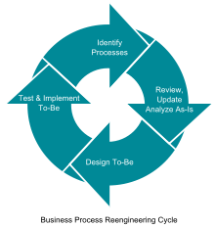

Business process modeling is a systematic method used to visually represent and analyze the processes within an organization. It involves creating graphical representations or diagrams that illustrate the steps, activities, inputs, outputs, and relationships involved in a specific business process. These models provide a clear and standardized framework for understanding how activities within an organization are carried out.

The primary goals of business process modeling are to enhance clarity, communication, and efficiency in business operations. Through the use of standardized symbols and notation, stakeholders can easily comprehend complex processes, identify potential bottlenecks or inefficiencies, and propose improvements. Common modeling techniques include flowcharts, BPMN (Business Process Model and Notation), and UML (Unified Modeling Language).

Effective business process modeling facilitates better decision-making, process optimization, and the implementation of technology solutions. It is an essential tool for organizations seeking to streamline operations, improve resource allocation, and adapt to changing business environments. As businesses evolve, process models can be updated to reflect changes, ensuring ongoing alignment with organizational goals and objectives.

**DESIGN THINKING FOR BUSINESS PROCESS MODELLING**

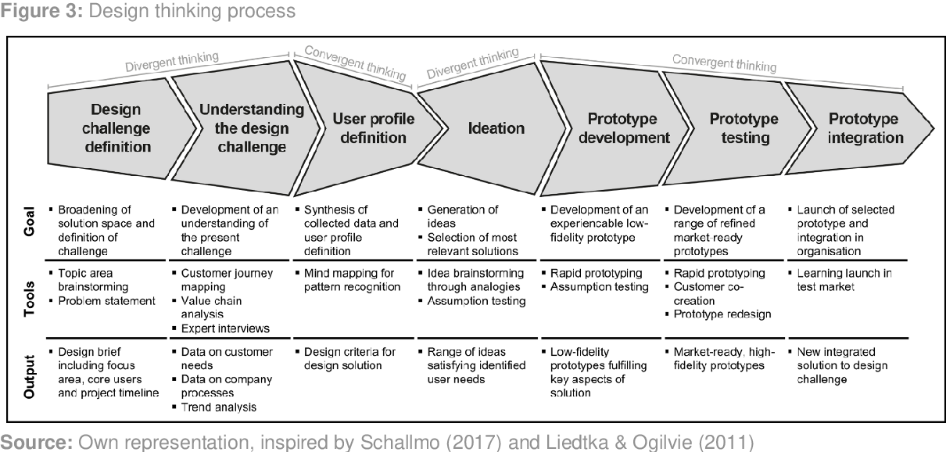

Design thinking, when applied to business process modeling, emphasizes a human-centric approach to problem-solving and innovation. It starts by empathizing with the end-users and stakeholders to understand their needs, challenges, and aspirations within the existing business processes. This empathetic understanding forms the basis for defining the problem and identifying opportunities for improvement.

The next phase involves ideation, where cross-functional teams brainstorm and generate creative ideas to address the identified challenges. These ideas are then translated into tangible concepts for refining and enhancing the business processes. Prototyping comes into play as a means to visualize and test these concepts, allowing teams to quickly iterate and gather feedback.

Through this iterative process, design thinking fosters collaboration and a willingness to experiment with new ideas. This approach encourages a mindset of continuous improvement and adaptation to changing business environments. Ultimately, design thinking in business process modeling not only results in more effective and efficient processes but also cultivates a culture of innovation and responsiveness within the organization.

**VIRTUAL COLLABORATION**

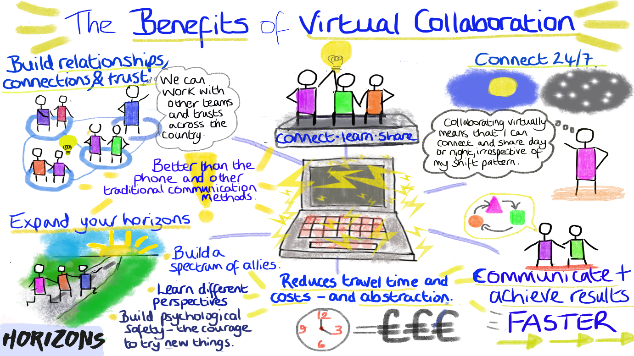

NVIDIA, being a technology company with a global presence, employs advanced virtual collaboration tools to facilitate seamless communication and cooperation among its distributed teams. Video conferencing platforms, project management tools, and messaging applications are integral to their virtual collaboration strategy. These tools enable real-time communication, document sharing, and collaborative project management, fostering a sense of connectedness among team members regardless of geographical locations.

The company invests in technologies that support remote work, ensuring that employees have access to the necessary resources and secure networks to collaborate effectively from different locations. NVIDIA employs cloud-based solutions to enhance scalability, accessibility, and data security in virtual collaboration.

Cross-functional teams are key component of NVIDIA's virtual collaboration efforts. These teams bring together individuals with diverse skills and perspectives, contributing to more comprehensive problem-solving and innovation. Agile methodologies, such as Scrum or Kanban, are integrated into their work processes, allowing teams to adapt quickly to changing priorities and requirements.

A culture of open communication is essential for successful virtual collaboration. Regular virtual meetings, updates, and transparent communication channels play a crucial role in keeping all team members informed and aligned with organizational goals. Additionally, NVIDIA encourages a culture of flexibility, allowing employees to manage their work schedules effectively while maintaining a focus on results.

**COMMUNICATION AND EMPLOYEE ENVIRONMENT MANAGEMENT**

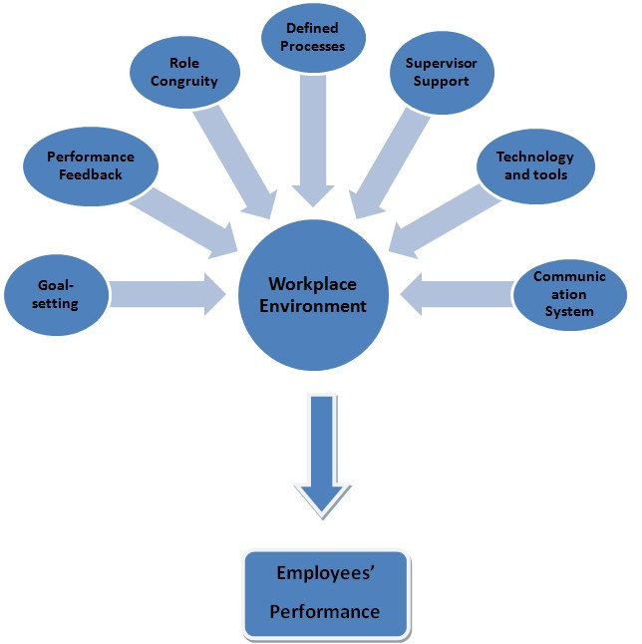

NVIDIA, as a leading technology company, is committed to fostering a positive and inclusive employee environment. Employee well-being and engagement are crucial components of their management strategy. The company prioritizes creating a culture that values diversity, equity, and inclusion, ensuring that employees feel a sense of belonging and are empowered to contribute their unique perspectives.

NVIDIA offers a range of employee benefits and wellness programs to support work-life balance. This includes flexible work arrangements, health and wellness initiatives, and professional development opportunities. Providing these resources helps employees thrive both personally and professionally.

Continuous communication is a key element of NVIDIA's employee environment management. Regular updates, town hall meetings, and feedback mechanisms are in place to keep employees informed about company initiatives, strategies, and performance. Transparent communication fosters trust and ensures that employees are aligned with the organization's goals.

In terms of professional development, NVIDIA invests in training programs and educational opportunities to help employees grow in their roles and advance their careers. This commitment to employee growth not only benefits individuals but also contributes to the overall strength and adaptability of the workforce.

NVIDIA prioritizes creating a collaborative and innovative work environment. Encouraging cross-functional collaboration, providing access to cutting-edge technologies, and fostering a culture of creativity and problem-solving contribute to the company's success and employee satisfaction.

**SCENARIO BASED PROTOTYPE**

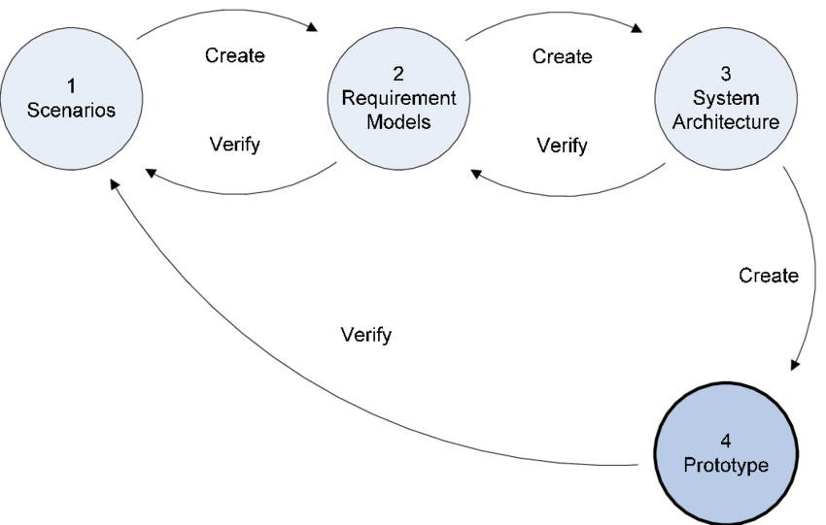

NVIDIA, being at the forefront of technology innovation, employs a systematic and user-centered design process for creating scenario-based prototypes. This process typically begins with a thorough understanding of user needs and requirements. NVIDIA's design teams conducts extensive research, including user interviews, surveys, and usability studies, to gather insights into user behaviors and preferences.

Once user requirements are identified, scenario-based prototypes are developed to simulate specific user interactions within a given context. These scenarios are often derived from real-world use cases to ensure that the prototype addresses practical and relevant challenges. The scenarios may encompass a range of user activities, allowing designers to test different aspects of the prototype's functionality.

NVIDIA uses advanced design and prototyping tools to create interactive and realistic prototypes. These tools enable designers to visualize the user interface, simulate user interactions, and refine the user experience iteratively. User feedback is crucial throughout this process, and prototypes are often tested with actual users to validate design decisions and identify areas for improvement.

The scenario-based prototyping process at NVIDIA is iterative and agile. Designers collaborates closely with cross-functional teams, incorporating feedback and making adjustments to the prototype based on testing results. This iterative approach allows NVIDIA to refine the user experience and ensure that the final product aligns with user expectations and business objectives.

Ultimately, the scenario-based prototype serves as a valuable tool for NVIDIA to communicate design concepts, gather stakeholder feedback, and make informed decisions before moving into the full development phase. It aligns with the company's commitment to delivering innovative and user-friendly solutions in the rapidly evolving field of graphics processing and artificial intelligence.

**STRATEGIC AND INNOVATIVE MANAGEMENT**

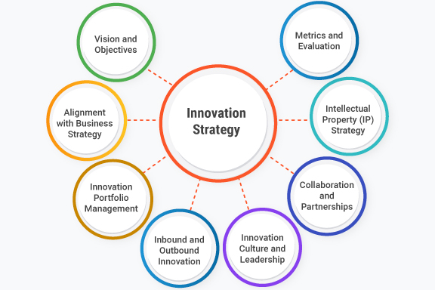

NVIDIA, renowned for its leadership in graphics processing and artificial intelligence, showcases a strategic and innovative management approach that has propelled its success. Strategic management at NVIDIA involves a keen focus on understanding the external environment and leveraging internal strengths. The company likely employs thorough market analyses to identify opportunities in emerging technologies while mitigating potential threats. This strategic foresight is essential for setting ambitious goals that align with the company's vision.

Innovation is a cornerstone of NVIDIA's strategic management, with a strong emphasis on research and development (R&D). The company is likely to allocate significant resources to foster technological advancements, staying at the forefront of cutting-edge solutions. This commitment to innovation extends beyond product development to include partnerships, collaborations, and acquisitions that strategically position NVIDIA in dynamic and evolving markets.

NVIDIA's strategic and innovative management is likely characterized by an agile and adaptive approach. The fast-paced nature of the technology industry necessitates a willingness to pivot strategies in response to market shifts. The company likely fosters a culture that encourages creativity and risk-taking, essential elements for staying ahead in rapidly evolving sectors.

Strategic implementation at NVIDIA involves translating visionary goals into actionable plans. The company's strategic initiatives likely include a mix of organic growth strategies and strategic partnerships or acquisitions to broaden its product and service offerings. Continuous evaluation of performance metrics ensures that the company remains on track to achieve its strategic objectives, with a readiness to recalibrate strategies as needed.

**INNOVATION MATRIX**

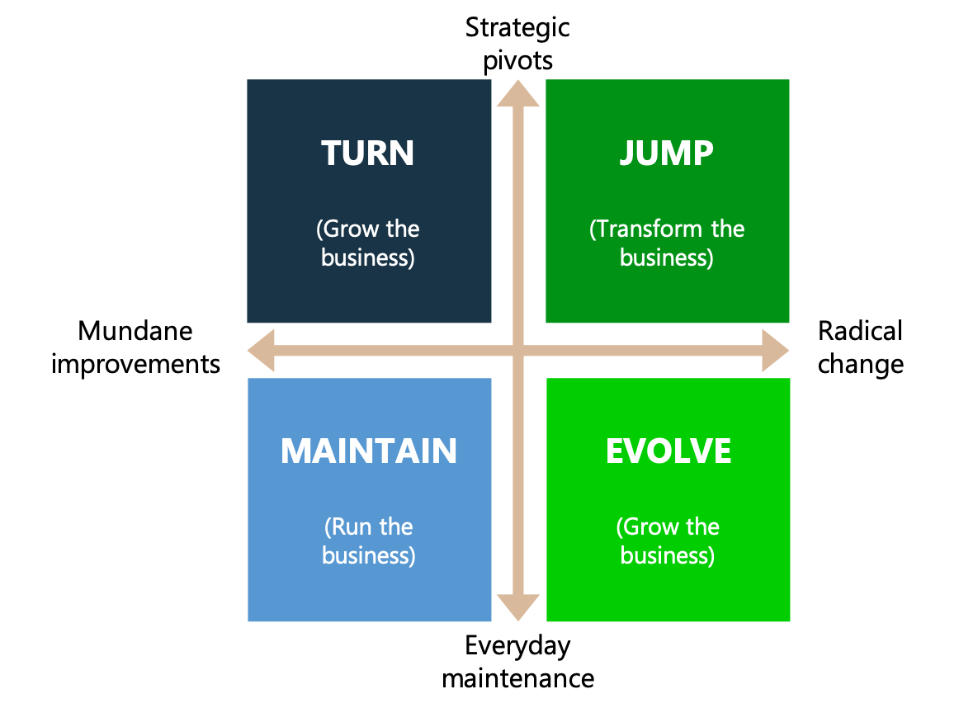

NVIDIA employs an innovation matrix to systematically evaluate and prioritize potential initiatives. In the high-impact, high-feasibility quadrant, the company focuses on groundbreaking projects that align with its core competencies and strategic objectives. This involves advancements in GPU technology, AI applications, or other cutting-edge solutions where NVIDIA's expertise is a competitive advantage.

In the high-impact, low-feasibility quadrant, NVIDIA explores visionary ideas that promise significant market impact but face technical challenges. While these projects require additional research and development efforts, they align with the company's commitment to pushing the boundaries of technology and innovation.

In the low-impact, high-feasibility quadrant, NVIDIA considers projects that, while technically feasible, offer incremental improvements or address specific market niches. These initiative help maintain a competitive edge in certain areas and contribute to a diversified product portfolio.

Projects in the low-impact, low-feasibility quadrant are deprioritized, as they may not align with NVIDIA's strategic goals or offer significant market impact. Resources are redirected toward initiatives with greater potential for innovation and market disruption.

NVIDIA's innovation matrix, if in use, is dynamic and adaptable, reflecting the rapidly evolving nature of the technology industry. The company's commitment to research and development, strategic partnerships, and staying at the forefront of emerging technologies suggests a comprehensive and strategic approach to innovation.

**STRATEGIC INNOVATION**

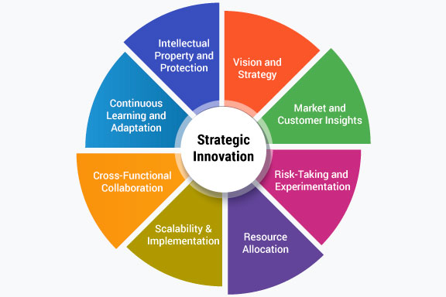

NVIDIA's strategic innovation is a dynamic and integral aspect of its success in the highly competitive fields of graphics processing and artificial intelligence. The company has consistently demonstrated a commitment to pushing technological boundaries through a strategic approach to innovation.

A key element of this strategy involves anticipating and responding to market trends and emerging technologies, aligning closely with the company's overarching vision. NVIDIA's emphasis on research and development serves as a cornerstone for strategic innovation, enabling the creation of cutting-edge products and solutions.

Whether advancing GPU technology for gaming, driving breakthroughs in AI, or exploring new applications for graphics processing, NVIDIA strategically positions itself at the forefront of innovation. The company's ability to leverage strategic partnerships, collaborations, and acquisitions further underscores its commitment to staying ahead in rapidly evolving industries.

By fostering a culture of creativity and maintaining a keen awareness of market dynamics, NVIDIA continues to shape the future of computing through strategic innovation that not only meets current demands but also anticipates and defines the technological landscape of tomorrow.

**SCOPE OF STRATEGIC INNOVATION**

NVIDIA's strategic innovation extends across multiple dimensions, including the advancement of GPU technology for gaming and professional visualization, breakthroughs in AI and deep learning, and the exploration of new applications for its core technologies.

The company's scope encompasses the development of cutting-edge hardware and software solutions, with a focus on addressing evolving industry demands and staying at the forefront of technological advancements. Strategic innovation at NVIDIA also involves collaborations and partnerships with industry leaders, academic institutions, and startups, facilitating a dynamic ecosystem that fosters creativity and accelerates the adoption of emerging technologies.

As the scope of technology continues to evolve, NVIDIA's strategic innovation remains pivotal in shaping the future of computing, with a forward-looking approach that positions the company to drive transformative changes in industries ranging from gaming and healthcare to autonomous vehicles and beyond.

**DESIGN THINKING WORKSHOP**

Design thinking is a problem-solving approach that focuses on understanding the needs of users and finding innovative solutions. Workshops are a common way for organizations to incorporate design thinking into their processes. Here's a general framework that may be adapted for use at NVIDIA or other organizations:

Define the Purpose:

Clearly define the purpose and objectives of the design thinking workshop. Identify the specific challenge or problem that the workshop aims to address.

Cross-Functional Teams:

Assemble cross-functional teams with diverse skills and perspectives. Including members from different departments encourages collaboration and a broad range of ideas.

User-Centric Research:

Start with empathy by conducting user-centric research. This might involve interviews, observations, or other methods to understand the experiences and needs of the end-users.

Problem Definition:

Clearly define the problem based on insights gathered from user research. Ensure that the problem is framed in a way that is focused on the users' needs.

Ideation:

Encourage brainstorming sessions to generate a wide range of ideas. This should be a creative and open-minded phase where participants feel free to express their thoughts without judgment.

Prototyping:

Select promising ideas and create prototypes. Prototypes can be physical models, digital representations, or even sketches. The goal is to quickly bring ideas to life for testing and refinement.

Testing:

Test the prototypes with actual users to gather feedback. This step is crucial for understanding how well the solutions meet user needs and identifying areas for improvement.

Iteration:

Based on feedback, iterate on the solutions. This may involve going back to the ideation or prototyping phase to refine and enhance the design.

Implementation Planning:

Once a viable solution is identified, create a plan for implementation. This may involve collaboration with different departments and stakeholders to ensure successful execution.

Documentation and Sharing:

Document the entire design thinking process and share the insights, solutions, and learnings with relevant stakeholders. This helps build a shared understanding and may inform future projects.

**FOCUS OF DESIGN THINKING WORKSHOPS**

Product Design and Development:

Design thinking can be applied to enhance the design and development of new products, ensuring that they meet the needs of users and offer a seamless and intuitive experience.

User Experience (UX) Design:

Improving the user experience is often a key focus. This includes understanding user behaviors, pain points, and preferences to create interfaces and interactions that are user-friendly and efficient.

Innovation and Research:

Design thinking workshops may also focus on fostering innovation within the organization. This could involve exploring new technologies, identifying emerging trends, and finding novel solutions to challenges.

AI and Deep Learning Applications:

Given NVIDIA's expertise in AI and deep learning technologies, design thinking workshops may center around the application of these technologies in various domains, such as healthcare, gaming, autonomous vehicles, and more.

Cross-Functional Collaboration:

Facilitating collaboration among teams from different disciplines is often a key aspect. Bringing together individuals with diverse skills, including engineers, designers, marketers, and others, can lead to more holistic and well-rounded solutions.

Solving Industry-Specific Challenges:

Design thinking may be applied to address specific challenges within the semiconductor and GPU industry. This could include addressing technical constraints, optimizing performance, or exploring new use cases.

**NEED FOR DESIGN THINKING WORKSHOP**

The need for design thinking workshops at NVIDIA, or any technology company, arises from several key factors. Design thinking is a problem-solving approach that prioritizes understanding user needs and creating innovative solutions. Here are some reasons why NVIDIA or similar companies might find design thinking workshops valuable:

User-Centric Innovation:

Design thinking places a strong emphasis on empathy and understanding the end-users' needs, challenges, and preferences. In a technology-driven company like NVIDIA, focusing on user-centric innovation ensures that products and solutions align closely with what customers actually want.

Complex Problem Solving:

NVIDIA deals with complex challenges in the fields of graphics processing units (GPUs), artificial intelligence (AI), and deep learning. Design thinking provides a structured and creative approach to solving intricate problems by breaking them down into manageable steps.

Cross-Functional Collaboration:

Design thinking encourages collaboration among cross-functional teams, including engineers, designers, marketers, and other stakeholders. This interdisciplinary approach fosters a diversity of perspectives, leading to more comprehensive and well-rounded solutions.

Adapting to Emerging Technologies:

The technology landscape is rapidly evolving, and companies like NVIDIA need to adapt to new trends and emerging technologies. Design thinking workshops provide a space for exploring and innovating in response to these changes.

Enhancing User Experience (UX):

In industries where user experience is critical, such as gaming and AI applications, design thinking helps optimize interfaces and interactions. Improving UX can lead to higher customer satisfaction and a competitive edge in the market.

Innovation and Creativity:

Design thinking fosters a culture of innovation and creativity. Workshops provide a structured environment for brainstorming and ideation, enabling teams to think outside the box and come up with groundbreaking ideas.

Iterative Prototyping and Testing:

Design thinking encourages the rapid creation of prototypes and testing with real users. This iterative process allows for quick feedback and refinement, ensuring that the final products or solutions better meet user needs.

Addressing Technological and Market Shifts:

The tech industry is dynamic, with constant shifts in technology and market demands. Design thinking allows companies to be agile and responsive to these changes, helping them stay ahead of the curve.

Employee Engagement and Satisfaction:

Involving employees in design thinking workshops can boost engagement and job satisfaction. It gives them a sense of ownership in the creative process and fosters a culture of continuous improvement.

Competitive Advantage:

By embracing design thinking, NVIDIA can differentiate itself in the market by delivering not just technologically advanced products but also ones that are intuitive, user-friendly, and aligned with real-world user needs.

**STAGES OF DESIGN THINKING WORKSHOPS**

Design thinking workshops typically follow a structured process with several iterative stages. These stages guide participants through understanding a problem, generating ideas, prototyping solutions, and testing them with users. Here is a common framework for the stages of a design thinking workshop:

Empathize:

Begin by understanding the problem from the perspective of the end-users. This involves conducting interviews, observations, and immersing participants in the users' experiences to develop empathy.

Define:

Clearly articulate the problem based on the insights gained during the empathize stage. Create a focused problem statement that frames the challenge and sets the direction for ideation.

Ideate:

Encourage participants to brainstorm and generate a wide range of ideas. Use ideation techniques such as brainstorming, mind mapping, or "How Might We" questions to stimulate creative thinking.

Prototype:

Select the most promising ideas and create low-fidelity prototypes. These can be physical models, sketches, or digital representations. The goal is to quickly and inexpensively bring ideas to life for testing.

Test:

Gather feedback by testing the prototypes with actual users. This stage involves observing user interactions, collecting insights, and understanding how well the solutions meet user needs. Iterate based on the feedback received.

Iterate:

Based on the feedback received during testing, iterate on the prototypes and refine the solutions. This may involve going back to the ideation or prototyping stage to make improvements.

Implement:

Once a viable solution is identified and refined through iterations, create a plan for implementation. This involves considering the practical aspects of bringing the solution to the market or integrating it into existing systems.

Reflect:

Reflect on the entire design thinking process. Discuss what worked well, what could be improved, and any unexpected insights gained. This reflection is crucial for continuous learning and improvement.

Share:

Communicate the outcomes and insights with relevant stakeholders. Sharing the results helps build understanding and support for the proposed solutions.

Scale:

If the solution proves successful and viable, consider how it can be scaled or applied to other contexts. Explore opportunities for broader implementation or adaptation.